You can design your map however you want ;D
This file just shows what needs to be included and is not designed in any way

Name of the Character
Franchise

Your Cosplay Name

WORK IN PROGRESS

- Reference
-use this space to show the jury the character you are cosplaying
-1/2 pictures

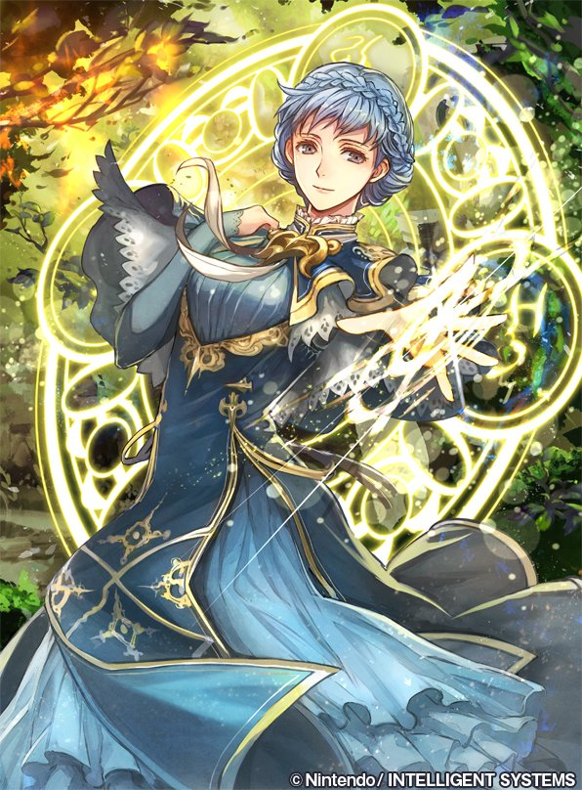

- Cosplay
-here, you focus on your cosplay and all the crafted and sewn pieces
-focus on each piece individually if you can! If the cosplay is not finished yet, just show us what you have been working on so far
-include pictures and descriptions of what you did, what materials you used, what steps you took, or what techniques you applied!
-example:
Corset
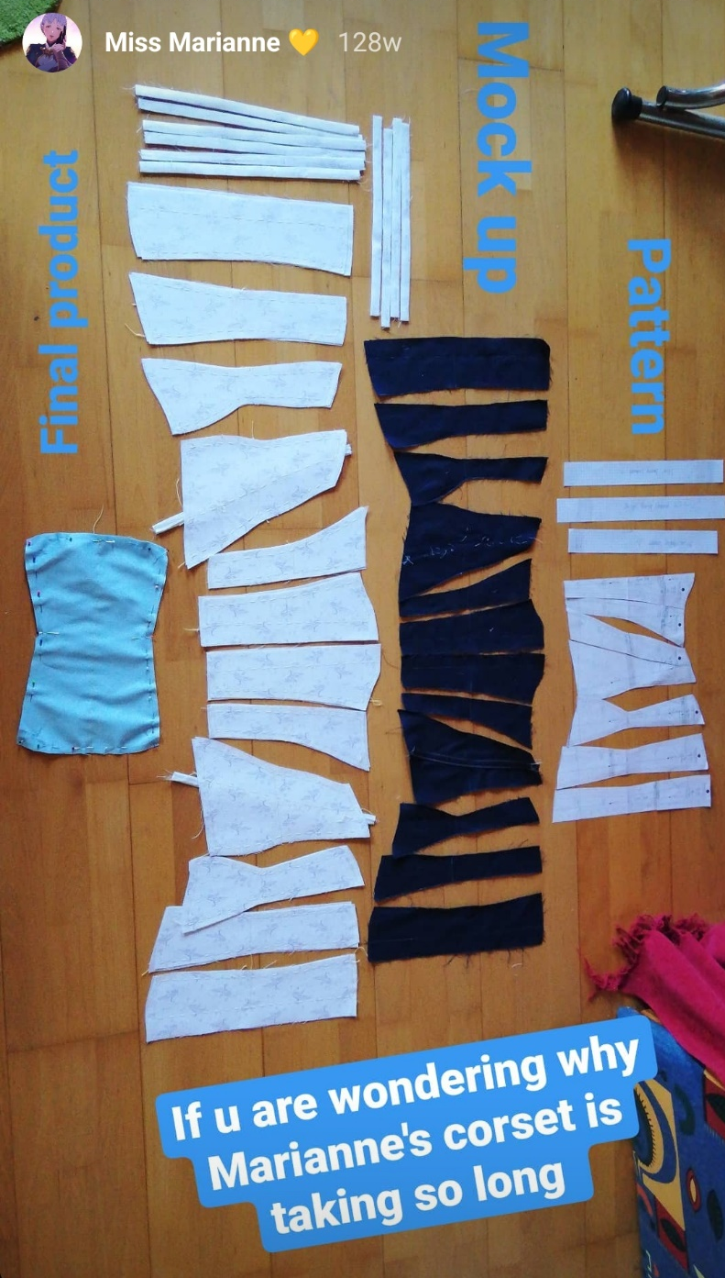
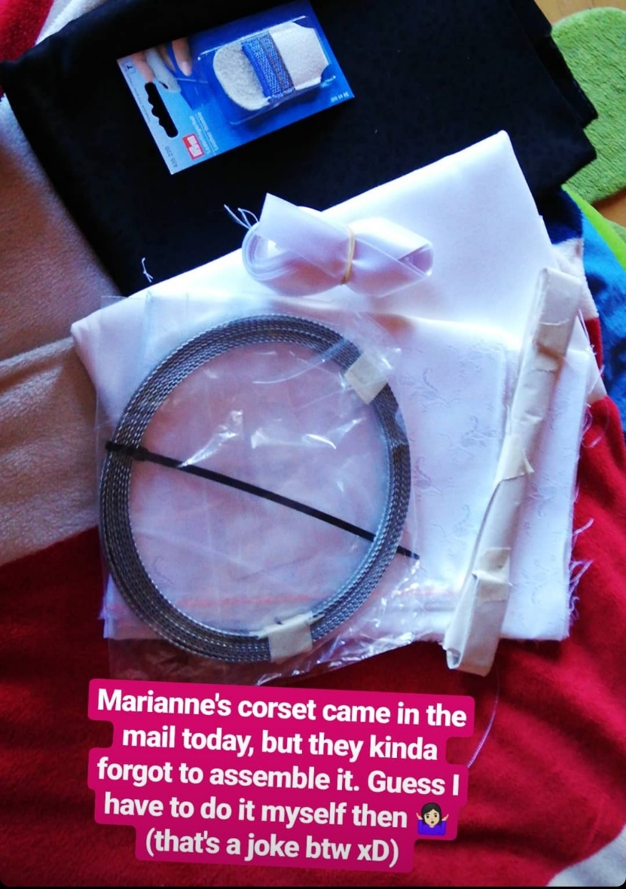
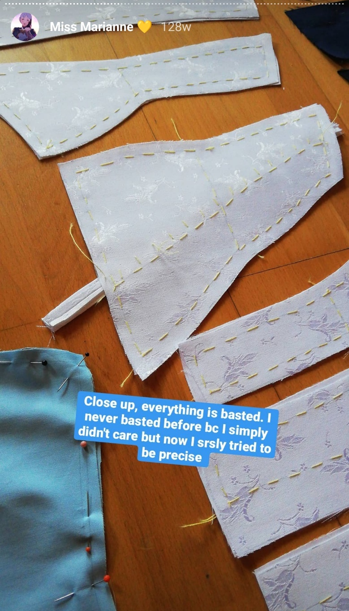
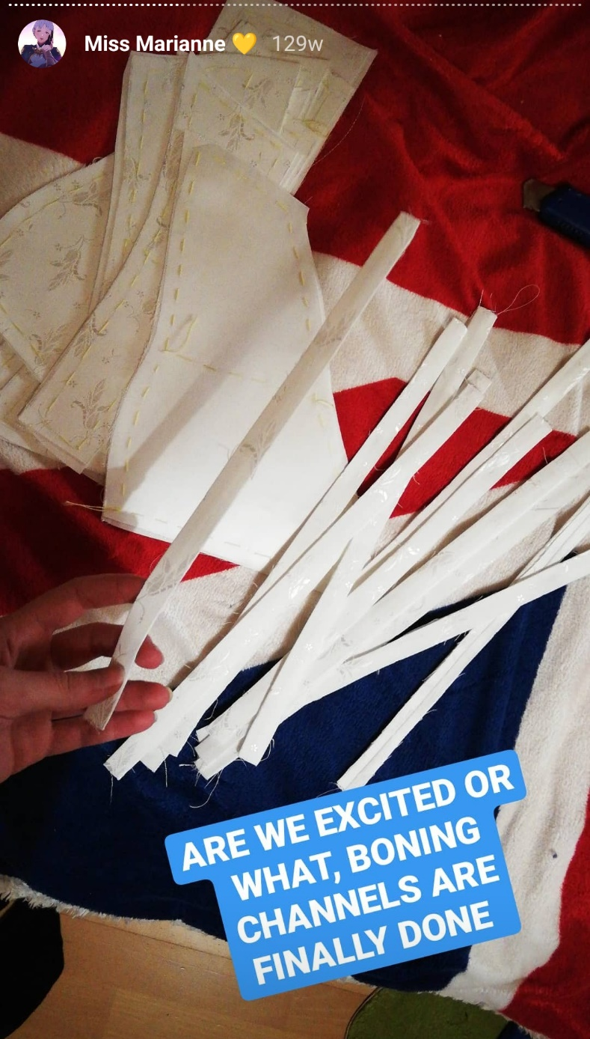

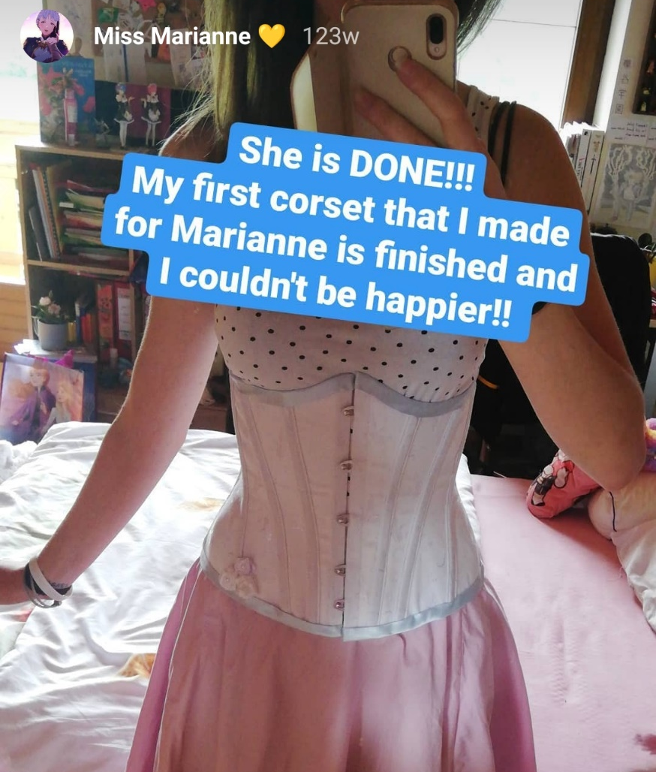

- Cosplay Pictures
-should your cosplay already be finished, show us how it looks like when you are wearing it
-this step is not obligatory though, we all know how it is to con-crunch

